NAME AND ADDRESS Date

Dear Name of parent/carer(s)

I am writing regarding your request to take (Student Name) out of school on Date until Date.

The law states that a planned absence from school should only be authorised for pupils in ‘exceptional circumstances’. Here at St Buryan School we recognise that there are occasions when it is appropriate to authorise an absence; we look at each request on its own merit before reaching a decision.

**Under the circumstances, we regret that on this occasion we are unable to authorise your request for absence.** If (Student Name) does not attend school on the dates concerned, the absence will be recorded as unauthorised. In cases where parents subsequently report their child as ill during this period, medical evidence may be requested to support this.

I urge you to reconsider your decision.

*If your child is absent from school without authorisation, you will be committing an offence under the Education Act 1996. We may submit a request to Cornwall Council for a Penalty Notice to be issued, in accordance with Sections 444A and 444B of the said Act. Penalty Notices are issued per liable parent, per child and each carry a fine of £80 if paid within 21 days or £160 if paid after this but within 28 days.*

*If your child is further absent from school without authorisation within any 3-year period, you will be committing a further offence under the Education Act 1996. We may submit a request to Cornwall Council for a Penalty Notice to be issued, in accordance with Sections 444A and 444B of the said Act. Penalty Notices for a second offence are issued per liable parent, per child and each carry a fine of £160, payable within 28 days. Importantly, fines per parent will be capped to two fines within any three-year period. Once this limit has been reached, other action such as a parenting order or prosecution will be considered.*

*Failure to pay the Penalty Notice may also result in legal action. If you are prosecuted and attend court because your child has not been attending school, you could get a fine of up to £2,500. Cornwall Council may also apply for the costs incurred in taking the matter to Court, including legal costs.*

*Absence not authorised by the school may also result in a prosecution in the Magistrates’ Court under Section 444(1) or Section 444(1A) of the Education Act 1996, leading to a fine of up to £2,500 and/or a custodial sentence. Again, Cornwall Council may also apply for the costs incurred in taking the matter to Court, including legal costs.*

*Money raised from fines is only used by the local authority to cover the costs of administering the system, and to fund attendance support. Any extra money is returned to the government.*

‘Parent’ as set out in Section 576 of the Education Act 1996, defines parent to include: natural parents, whether they are married or not; any person or body who has parental responsibility for a child (as defined by the Children Act 1989) and; any person who, although not a natural parent, has care of a child. Having care of a child means a person with whom a child lives and who looks after a child, irrespective of what their relationship is with said child.

I would like to offer you the opportunity to contact {enter staff contact or team} at {enter St Buryan} if you would like advice or support in helping your child attend more regularly. {Enter St Buryan} is committed to maximising the education of all its pupils and aims to work with parents to ensure this can be achieved. If you would like to discuss this matter further, please contact the school.

Yours sincerely

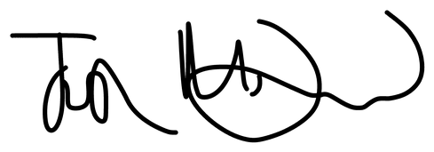

Mr Joshua McDonald

Headteacher